**Terrain**

**Objective**: Establish a world

1. Right click in the **hierarchy**, select **3D object**, and select **Terrain**.

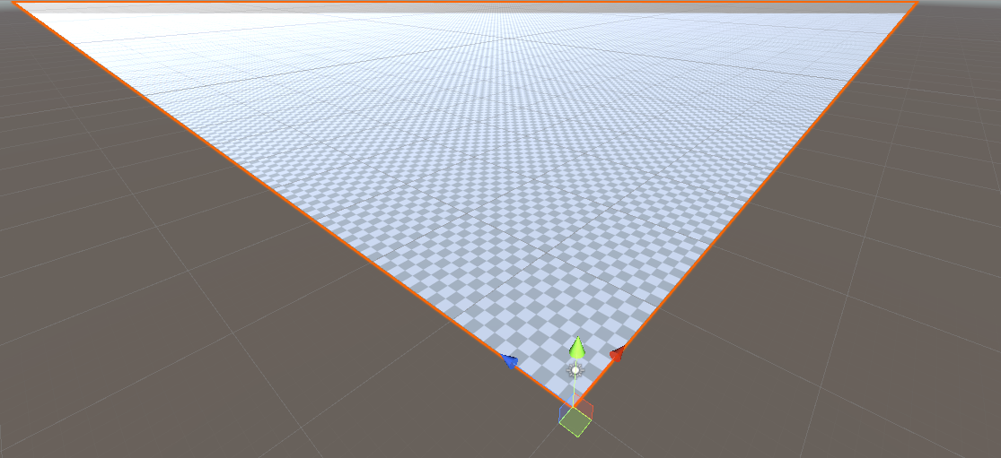

1. Select terrain, go to the inspector, and in the terrain component select the **gear icon**. This is your Terrain Settings.



1. Scroll down and find the **Mesh** **Resolution** section. Make the **terrain** **width** and **length** **1000** units each. One thing I want to note is that Terrain Height controls how HIGH our terrain will be allowed to increase when we start making mountains.

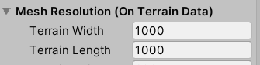

1. Let's change the **X** and **Z** **position** for the terrain to **-250** each that way we're not just off in a corner.
2. In the inspector lets click on the Paint Terrain button which is second button under terrain component.



1. Select any of the **brushes** and start “drawing” on the terrain by holding the left mouse button. It works as a height map which means when you “paint” on the terrain you’re actually **raising** the **height** at that location.

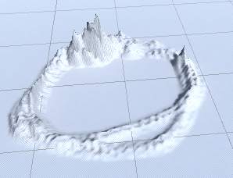

If you hold down the **shift** button while drawing it will **lower** **the** **height** at that location. You can also increase the brush size to increase the area of the terrain you affect. The **opacity** controls the *strength* in which these changes occurs.

You can change size of brush using **[** or **]** keys.

1. Let change the **Directional** **Light** **intensity** to **0.6** so we can see our terrain better.
2. Under the **Paint Terrain** button there’s a dropdown menu that should currently say **Raise or Lower Terrain**. Let’s change it to **Set Height**. Find the **Height** box and set it to **100**. Finally select **Flatten All**.

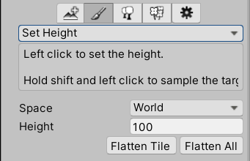

This should have raised the height of all of your terrain to 100, so now if you change the mode back to **Raise or Lower Terrain** when your Left Click and hold shift you should be able to create valleys up to 100 units deep.

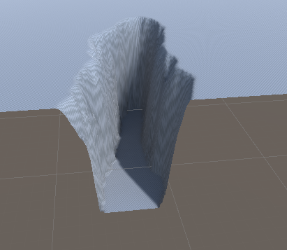

1. Change the **Y position** for your Terrain to **-100** since technically right now its sitting 100 units above our origin.
2. To keep our world feel immersive lets go ahead and create mountains all along the edge of our terrain so that at no point our player view is vast emptiness. Feel free to experiment with brush size or brush during this. Also create a mountain in the middle. Its completely temporary so don’t worry about getting it perfect.